Data Analysis

Name: Leonard Makiputin BSIT 2 – A

Activity 1
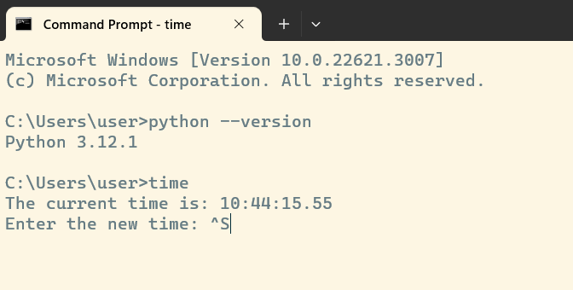

Activity 2
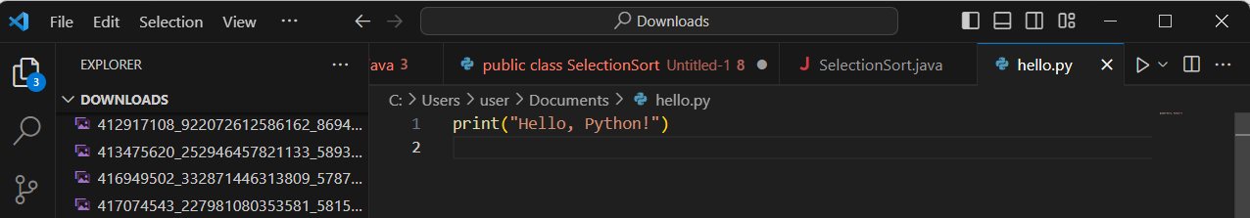

Activity 3
